**Is it legal to buy old books and establish a book rental business in India?**

It is legal to establish a rental business of old books in India. There are many people doing this business. There are also libraries, where we could find such rental books. The library book rental service goes great. The books got for rent should be handled safely or else the customer has to pay extra for the damage he/she has made.

There are also other rules to rent books. If the customers lose the book somewhere, the same book should be bought and replaced or the amount for the books should be paid. There is also a due date given for the rent books. There is nothing illegal in this business.

Happy Learning

**Where can I buy old books online?**

There are few small stores from where you can get second hand books online.

Some of them function as a listing website where they connect buyers and sellers. (Almost same as OLX/Quikr). Some of them work as online bookstores like Amazon/Flipkart and you can directly buy from them.

Listing down all the places where you can search the same (*courtesy - multiple threads*):

**Platforms working similar to OLX/Quikr:**

[StudentDesk](http://studentdesk.in/) - Has mostly college books.

[Lenro](https://lenro.co/) - Works as a lending platform where you can lend, borrow and exchange books

[Bookadda](http://www.bookadda.com/old-books) - Takes a slightly different approach. Authenticates you from Facebook.

[Mycollegeadda](http://www.mycollegeadda.com/) - Has college books.

**Platforms working similar to an E-com store:**

[AbeRuk](http://www.aberuk.com/) - Good assortment. Just got funded

[Junglee](http://junglee.com/)- Part of Amazon India. Assortment of 17K+ books.

[Bookchor](http://www.bookchor.com/index) - Varied inventory

[Bucketbolt](https://bucketbolt.com/) - Sells mostly Academic Books.

[TheCollegeStore](https://thecollegestore.in/) - Sells mostly Academic books

[TossBooks](http://www.tossbooks.com/index.php?route=common%2Fhome) - Has Academic as well as Novels content.

[Yobooks](http://www.yobooks.in/) - Varied Assortment

[Infibooks](http://www.infibooks.com/) - Assortment decent.

[Bibiliofreaks](http://www.bibliofreaks.com/) - Decent and varied assortment.

Some of these websites may not cover an exhaustive list of pincodes. You might want to check which all places they cover. Also, if you are a little wary of using them, probably place a COD order.

Everyone today read a book. Be it, Someone who is in school, college, or even the one who is preparing for the competitive exams. We know, It’s not prudent often to buy a new book. Okay, let me justify my point. So, you need to read it for say, 1 year or be it 2 or 3 and after that you are going to add another few Kilograms to your bookshelf. So why not buy a second-hand copy of the same, saving a few bucks. I mean who don’t want to save some money !!

After going through a few alternatives, I’d like to suggest [**Starter Group**](https://www.startergroup.in/). They are an e-commerce business store of second hand and New books in Delhi and deliver books at every state of India also out of India too like Indonesia, Dubai, China etc. Most intriguingly they offer a gamut of books belonging to Beauty And Personal Care, School Level, Engineering, Management, Competitive exams, novels. All of these can be bought easily through their website, also there is no need to worry for the transaction process as they offer fully secure transaction, accepting almost every card, net banking and above all Cash On Delivery is also available. For every order you will get tracking id also on your email which you provided during your order processing.

Just visit [**Starter Group**](https://www.startergroup.in/)and no matter what reader you are, this site has its own wide collection and will definitely help you find yours and get all the books delivered at your home.

**In India, peoples are mostly attracted towards mouthwatering discounts, various ordering options, free delivery, easy return policies & most important pocket-friendly cost.** Why go with other websites if you are just looking for books? Some websites right now not that much bigger but they are providing good services & offers like big website.

**Is renting books online a good idea for startup?**

I am of a different opinion here. Consider these only mine.

Lets discuss about problem and solution you can offer given you have to earn, after all you will run a business.

There are two aspects :

1) You will rent books by your own. I meant you have books purchased and will rent to people who are in need and they will return you later on. You might consider keeping some guarantee (token amount) and return it later on. So indirectly you are selling book and taking it back based on its condition of course and deducting some depreciation. So overall picture sounds, a place for used books. Not a bad idea but do research of existing players, total capital, working capital etc etc.

2) You will be middle man between two parties. X has a book and Y needs that, Somehow you managed to make them contact each other. Now what!

2.1) If X is dealing with all the stuff(token money, sending, receiving) by his own then it is troublesome for all customers and they could do same thing somewhere else as well; no that much value add here.

2.2) If you operate on behalf of X and make sure process is smooth for both parties, then getting book from X and sending to Y and then reverse the process after some time. Operational cost!!

Overall, each transaction can lead to more expenses I can think of. If you really have a good plan on how to execute, DO NOT THINK much and give a try to version 0.1; Version 1 will eventually come with your learnings.

Hope it helps!

**Is renting books online a good idea for startup?**

A big NO - As a Startup Idea

Maybe/yes- From business Point of view(You can start in colleges)

Rent a book or Even selling books online, both are outdated Ideas, and have been implemented by many people.

**Why I Said No:**

* People take things on rent which they can't buy.
* Even If they will, they will not pay brokerage as like in real-estate, because they can always buy it then after use, sell it.
* **Books are not the future. Products like E-books, Kindle are.**

Have you tried Kindle? It has the power to carry thousands of book with you.

'Think of a world where students are carrying just a Kindle kind of device for all the subjects and notes.' How cool will it be!!!!!

Think of writing pad, in which students can write and automatically the pages will get stored on cloud server, and they can share with anyone, and even submit homework online, etc

Start-up Idea should be**Problem solving with the Vision of Future.**

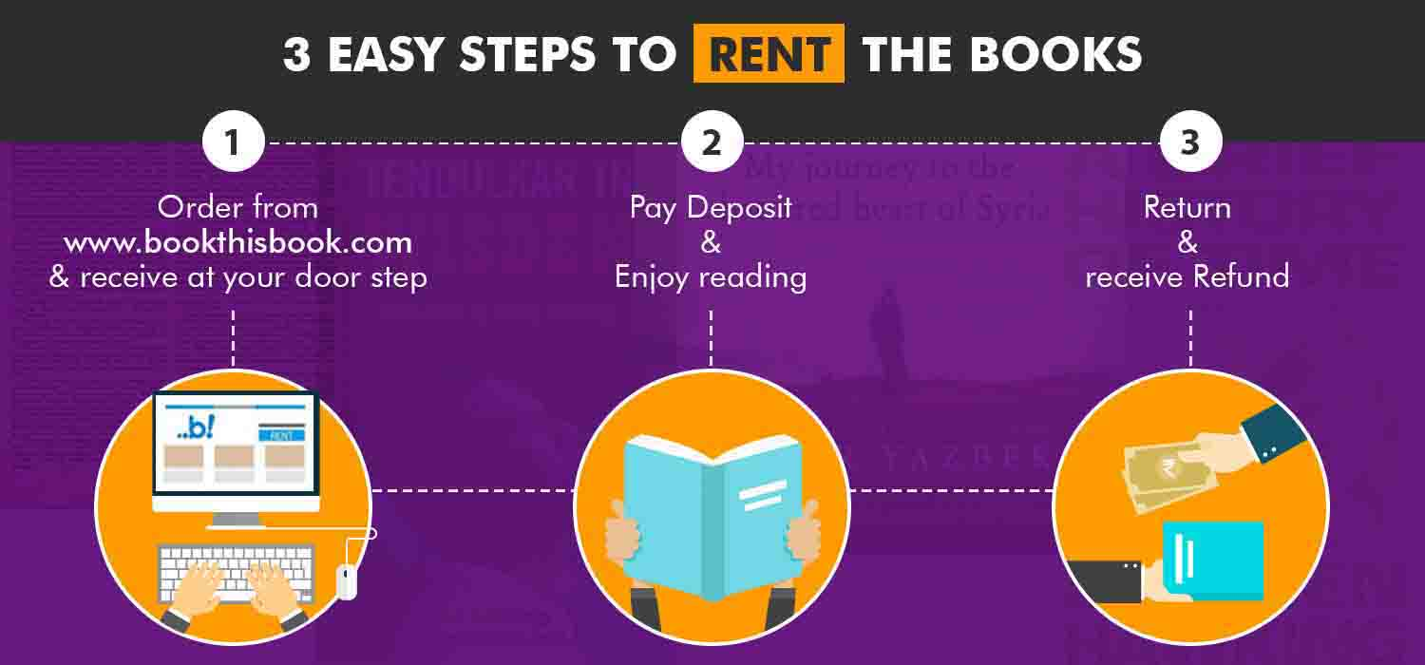

Renting book is a good idea.

This help the book lover to read all the books he like without paying the heavy cost of the books just buy renting the book.

This renting books online is a very critical business to start with. Even big players like Flipkart and Amazon don't have the books renting portal since its very costly to deliver and pick up the books from user.

The only portal which rents books is [www.bookthisbook.com](http://www.bookthisbook.com/)

The more people rent the book the more the people save money.

Ucanrentbooks.com is a cheaper alternative of renting buying new or used textbooks. We understand how expensive college textbooks can be, so we offer you a price which is never given by anyone before the 80% off deal.  
Simply submit order query of the books you need and we will provide you Free Shipping both ways. We offer books on rent for complete Semester that means complete 6 months. If you decide that you need to keep your book rental for a longer period, you can add 15 days as grace period with no charge. Most of our textbook rentals ship within 3-4 days, some quicker within hours. Once you receive the rented textbook, study with them and ace your classes. Don’t worry when our rental period gets over we will come and get our books back free. And if there is any problem with your shipment like wrong book delivered and torn pages which are a rare case you can return back to us within less than 10 days return back policy.  
Main Features:  
a. Free delivery and pick up  
b. 80% off from MRP  
c. Books of every Course and Semester  
d. 15 days grace period after end of rental period  
e. 10 days return back policy  
f. Live customer support

Ucanrentbooks.com not only rents college books but we also rent novels, biographies, religious books on 60% off from MRP for 6 months. In other words tell us what you want to read and we deliver it to your the best price in the industry.  
Currently we are operating in Delhi region only but our target is to expand nationwide to serve our students friends.  
So Rent your college semester books online in the best deal ever available in India.

https://www.crazyaboutstartups.com/directory-startups/listing/ucanrentbooks-com-online-book-renting-website/?doing_wp_cron=1599761214.1421489715576171875000

**How to Start a Book Rental Business**

At times people cannot always afford to purchase the book they wish to read and that is what makes the book rental business ideal as it is a cheap alternative to experiencing expensive books without purchase.

Bear in mind that people will be interested in renting books that are popular and that these books must be preferably heavy duty or hard bound to last longer. Though since you will just be starting the business at least have these books clean and well covered. These are also things that should be checked regularly.

Draft out your plan for the business such as the general guidelines and rules and regulations for rental. You will need to list the books you plan on buying as well for your archive. There are several books to choose from and you may even consider purchasing old classics or used books if you please to add to your stock. With this in mind also remember that it is the popular book that usually sells so it would be best to have more copies of popular books available to your customers.

Before you purchase anything for your business you will need to know your budget. It is always good to set a strict budget before starting your business in order to have a clear draft of the expenses you will be making. To draft this budget you will need to list down all the things you need and what you will require to service your customers. Include in the budget draft if you plan on hiring help or other employees. Search suppliers for the prices and compare them accordingly. Price the [book](https://www.startupbizhub.com/how-to-open-a-bookstore-and-cafe.htm) rental according to its popularity as more people will want to rent out the popular books more than others. With the financial matters you may want to consult an [accountant](https://www.startupbizhub.com/tax-accountant-job-description.htm) to make sure everything is in order.

Once you decide on the things you want to purchase you may now stock your location. By this time you must have decided upon where to start your business. The location may be either at home or at a separate commercial area. It is important to have all the legal documents ready for this as you will not want to encounter any legal problems as your business enters operation. Furnish your location accordingly and take care of the finishing touches.

The important thing to remember in this type of business is that you need to continually purchase new sets of books as the business progresses. The customers will want to have a wide variety of books to choose from and to accomplish this you will need to have new books available regularly. Target best sellers and popular book as these are essential in your rental business. You may also want to purchase books from used book stores and book sale outlets

<https://www.startupbizhub.com/how-to-start-a-book-rental-business.htm>

**I want to start an online book rental business. Does anyone have a step by step procedure on how to start, launch and systematize that type of business?**

<https://www.quora.com/I-want-to-start-an-online-book-rental-business-Does-anyone-have-a-step-by-step-procedure-on-how-to-start-launch-and-systematize-that-type-of-business>